**Rose Leaf Disease Detection using Image Segmentation**

Pradeep Kumar Singh

Department of Computer Science Engineering

Jaypee University of Information Technology

Solan,India

pradeep.ksingh@juit.ac.in

Yugal Kumar

Department of Computer Science Engineering

Jaypee University of Information Technology

Solan,India

yugal.kumar@juit.ac.in

Shaswat Sood

Department of Computer Science Engineering

Jaypee University of Information Technology

Solan, India

[shaswat.sood@gmail.com](http://shaswat.sood@gmail.com)

Nitika Sharma

Department of Computer Science Engineering

Jaypee University of Information Technology

Solan,India

[sharma.nitika0599@gmail.com](http://sharma.nitika0599@gmail.com)

**Abstract: *Agriculture plays an important role in the process of economic development of a country. Agriculture provide human being with food, raw materials and livelihood. Various services such as soil conservation, water conservation and maintenance of soil fertility is performed by agriculture biodiversity. Using Image Processing tools, we can achieve our goal and detect degradation of plants. Old methods for detecting disease in plants like naked eye disease detection was difficult to carry, time consuming when the size of farm was large , less accurate and not much effective. But by using computer vision toolbox detecting disease was convenient and efficient. The aim of our project is to make disease detection an easy process by applying various modern techniques. Little computational effort can be used to classify and recognize the experimental results. Training sample must be large in number to improve disease identification rate.***

**Keywords: HIS model, Image processing, Histogram equalization, Histogram.**

**1. Introduction**

Plant disease is one of the main reason that do reduction in the quality and is responsible for its degradation. The ability of disease diagnosis in early stage plays a crucial role in order to be able to timely cure and control such disease. Some diseases in plants are not even distinguishable. So, Images play a very significant role in information analysis. The aim of our paper is to analyze the disease detection in Rose leaf plant. Roses are susceptible to diseases that can lead to leaf damage, though most don't cause leaf to curl. The fungus typically targets plants in too much shade, so growing plants in an area where there is more sunlight is more preferable and reduces the risk of disease. Same thing happens when we water our Rose plant as powdery mildew only spreads on dry surface. Black spot is most common disease of rose bushes and if it is left ignored, it can cause huge damage to your whole plantation. They are caused by fungus Diplocarpon rosae, black spots begins just as its name suggests, with black spots showing upon the surface of the leaves. The paper is organized into various sections which include Introduction, Related work, Results, Conclusions, Challenges, Future Scope , References.

**2. Related Work**

This section covers the details about the literature review. The current section is classified into two categories, in section 2.1, the gathered information has been tabulated and further explained. In section 2.2, the research techniques used have been discussed.

**2.1 Literature Review**

This table consists of various techniques and methodologies proposed by various research papers. It gives us brief description of objective, contribution and goals.

|  |  |  |  |
| --- | --- | --- | --- |
| **Study Id** | **Objective** | **Contribution** | **Goals** |
| 1 | Using Image Processing disease detection in remote area plants. | Appropriate enhancement of images uses histograms. Image segmentation is used for detection of adequate diseases. Spot on the image can be detected by texture segmentation. Rough, silky, bumpy texture of image can be identified by texture analysis. Texture analysis uses co-occurrence matrix method, which uses Hue Saturation Intensity color space representation. | * K-mean clustering * Back propagation * Neural Network * Co-occurrence matrix method * Otsu Segmentation |
| 2 | Using texture features classification of plant leaf disease and detection of unhealthy region of plant leaves. | Corresponding values in feature library are compared using minimum distance criteria. Finite set of elements were drawn by using Support Vector Machine(SVM). For training the system small amount of the leaf images were used and remaining served as the set for testing. | * RGB image acquisition * Color transformation * Masking and removal * Mapping of RGB * Segment the components * Computation of texture * Classifier |
| 3 | Biotic stress detection in precision crop protection using advanced machine learning methods. | Non-Linear SVM and Neural Networks gave good prediction accuracies than linear approaches. On the other hand, best classification performance in the study was given by the SVM compared to Neural Network. Grey scale image was used for extraction of texture features. Using machine learning methods high dimensional data was analyzed. | * Support vector machine * Support vector regression * Neural networks * HSV-color space(Hue Saturation Value) * Image Segmentation * K-Means clustering * RGB Color |
| 4 | Detecting, quantifying and classifying plant diseases using digital image processing techniques. | Background was discriminated from the leaf and then damaged regions were separated from healthy surface Final estimate was given by the ratio of no. of pixel damaged and no. of pixels of leaf. Red and green component of image were combined using chlorosis algorithm for determining the yellowness of leaf. Blue component was used to separate leaves from background. To identify the necrotic region, Necrosis algorithm was being used. | * Neural Networks * Thresholding * Dual-segmented regression analysis * Quantification * Color analysis * Fuzzy Logic * Knowledge-based system * Sobel operator * Chlorosis algorithm |
| 5 | Image recognition technology identification of Alfalfa leaf diseases. | Arithmetic square root of total features was selected from decision tree. For e.g. if arithmetic square root was decimal, then rounding up the decimal gives the number of features randomly selected by each decision tree. Disease recognition gave the satisfactory recognition results. This indicated that features extracted from lesion images were efficient. | * Fuzzy *C*-means clustering * *K*-median clustering * Euclidean distance * Logistic regression analysis * Naive bayes algorithm * Cart linear discriminant analysis |
| 6 | Using pattern recognition techniques identification of disease in rice plant. | The infected part of the rice plant was being classified using SOM(Self Organizing Map)neural network where the images were being obtained by doing the extraction of the infected part while four different types of images were being used for the testing purposes. | * Image processing and pattern analysis methods. * Hue Intensity Saturation (HIS) model * Bi-level thresholding method * Boundary detection algorithm using 8- connectivity method * Self organizing map (SOM) |
| 7 | Hybrid intelligent system detection of disease in grape leaf. | The system demonstrated automatic diagnosis capability with very effective performance for the further agricultural product analysis/inspection system development. | * Genetic algorithm for optimization. * Support vector machines for classification. * Artificial neural network. * Back-propagation neural network(BPNN). * Anisotropic diffusion technique. * Modified self-organizing feature map(MSOFM) |
| 8 | High-Throughput Stress Phenotyping in Plants using machine learning. | This review gave us an overview of Machine Learning and with the various advantages of machine learning in the future. | * High-throughput phenotyping (HTP) * High-throughput stress phenotyping (HTSP). * ML algorithms * Support vector machines (SVM) * Artificial Neural Networks(ANN) |
| 9 | Using image segmentation and soft computing techniques detection of plant leaf disease. | Algorithm optimized continuous and discrete variables effectively. It searched for large data samples of the cost surface with large variables being processed at the same time. | * Genetic algorithm * k-nearest-neighbor method * Machine learning based recognition * Color Co-occurrence Method * Artificial neural network (ANN) |
| 10 | Recognizing plant disease symptoms automatically using algorithm of image processing. | Correct target shown in the images can be identified by the strength of the algorithm. Different images vary in intensities which will definitely help in the future. | * Image pre-processing * Image enhancement * Image segmentation * Image post-processing |

**2.2 Proposed Methodology**

The image of rose leaf is acquired using digital camera. Then image processing techniques were applied to the captured image in order to extract useful features. After that, various analytical techniques were used to classify the images according to the specific problem the following figures tell about the implementation technique to detect disease in the leaf.

**HSI color model**

The HSI color model is a significant module for image processing application.

Every color in HSI model is represented by using 3 components: Hue(H), Saturation(S), Intensity(I)

* Dominant color as perceived by an observer is attributed by Hue.
* Addition of white light or purity in image refers to saturation.
* Amplitude of light present in the image is referred as intensity.

**Histogram**

* Intensity variations in a gray scale image was expressed by a histogram.
* Enhancement operation were chosen using histogram information.
* ‘Histeq’ function automatically manipulated intensity of image.
* Based on frequency of image the values of digital number were enhanced in histogram.
* Wider range were assigned to corresponding histogram peaks. .

**3. Results**

This section includes the results and findings of our experiment. The Figure 1 depicts the Normal leaf Histogram and Histogram Equivalent Image, Figure 2 depicts Normal Image HSI Component, Figure 3 depicts Diseased leaf Histogram and Histogram Equivalent Image, Figure 4 depicts Diseased Image HSI Component.

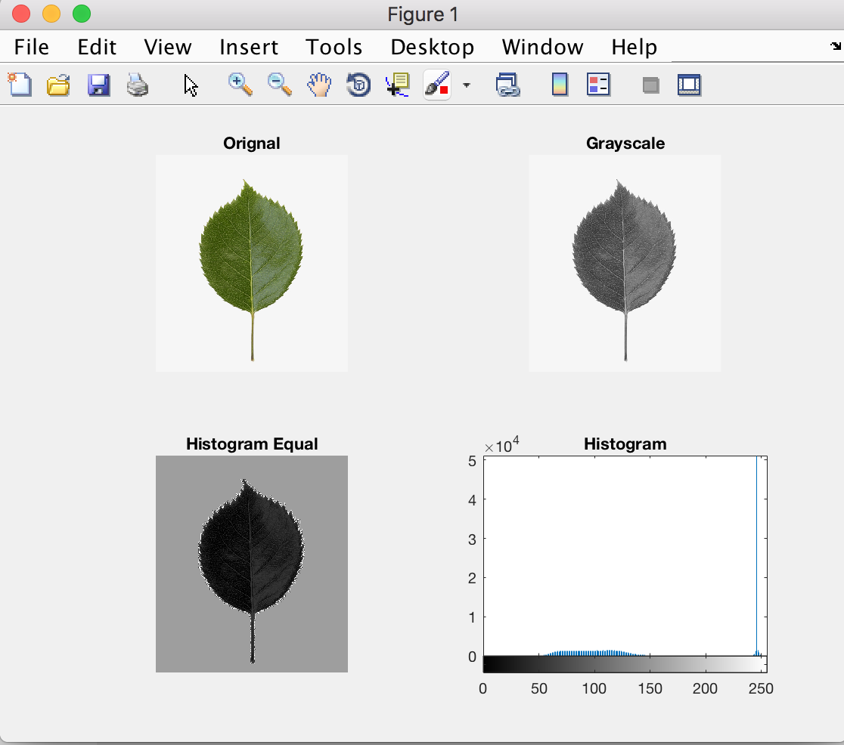

**Figure 1. Normal leaf Histogram and Histogram Equivalent Image**

In Fig.1 we have discussed the healthy or good leaf which is free from dis

-ease. Here we have studied the Gray scale image, histogram, histogram equ

-alization of image.

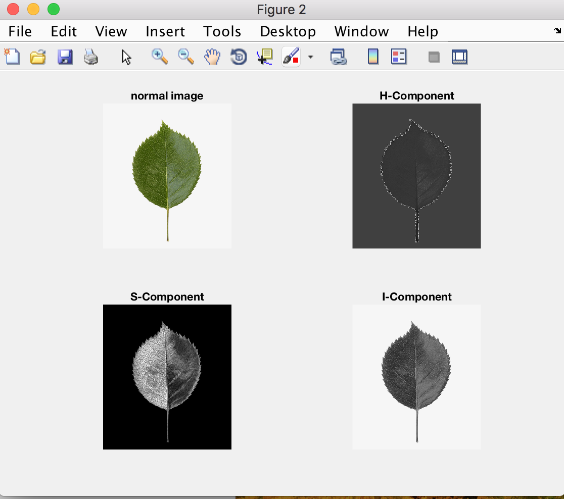

**Figure 2. Normal Image HSI Component**

Figure 2. Shows the H-Component, S-component, I-Component separately

where Hue(H), Saturation(S), Intensity(I).

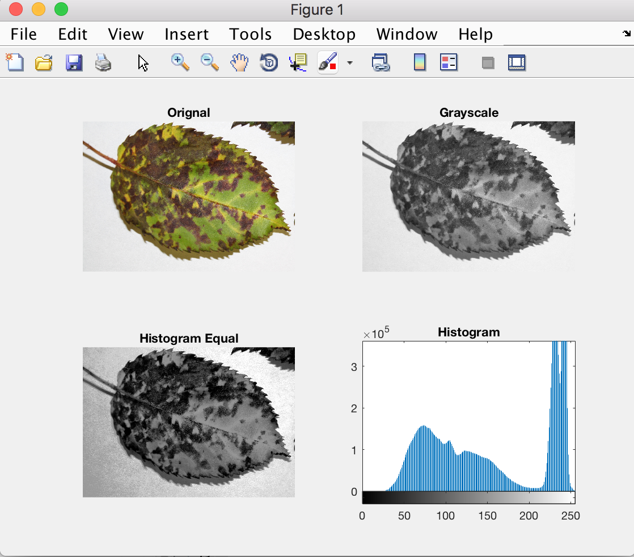

**Figure 3. Diseased leaf Histogram and Histogram Equivalent Image**

Figure 3 shows the Diseased Rose Leaf. Here we have studied the Gray

scale image, histogram, histogram equalization of image. We can very

well observe the variation in the Histogram.

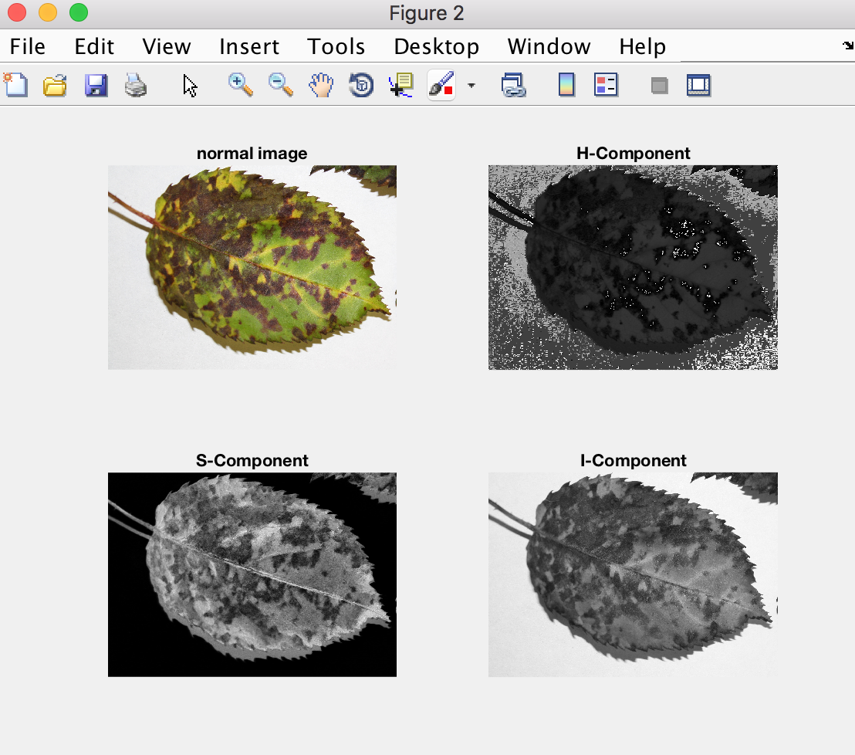

**Figure 4. Diseased Image HSI Component**

Figure 4 shows the variation in the HSI component of the diseased

Rose Leaf. The diseased portion of the leaf is having different texture

when compared with the disease free portion of the leaf. Dominance

is perceived by Hue component. Purity in image refers to saturation

and lastly Amplitude of light present is referred as intensity.

**4. Conclusions**

By analyzing the above result, we are able to come to this conclusion that Figure 1 and Figure 3 were depicting huge variations in the histogram. The histogram of a diseased free image was showing less variation where as the histogram of diseased image is showing huge variation. On visualizing the histogram variation, we can easily detect the variation and similarly by analyzing Figure 2 and Figure 4 which were depicting the respective HSI color model, which was showing huge variation and will help in the detection of the diseases.

**5. Challenges**

Since the approach adopted in our research paper involves some innovation and usage of modern technology, it will surely have some hindrances in its way. Image of the diseased leaf should be properly captured with more precision and clarity. There is a need of large training sets. Not using real-time monitoring is also an issue of concern. Algorithmswhich are using very specific technique must not be used. Huge variation in results can lead to inconsistency in our system. Creating awareness is an essential part of the implementation.

**6. Future Scope**

A lot can be done in this field. By using efficient pattern recognition techniques, the system will be able to do the timely diagnosis of the field problem and the suggestion will help the farmers to take the appropriate measure to increase the quality of the plant. It helps in the optimization of variables with highly minimal cost surfaces. Plants are continuously monitored by the Real-time monitoring and alarm will be issued as soon as disease is detected. Training sample can be increased to improve disease identification rate. It will not only reduce the development cost in the future but also save the environment.

**7. References**

[1] S.Bashir, N.Sharma, Remote Area Plant disease detection using Image Processing, IOSR Journal of Electronics and Communication Engineering , Volume 2, Issue 6 ,pp.31-34,2012.

[2] S.Arivazhagan, R.N.Shebiah, S.Ananthi, S.V.Varthini ,Using texture detection features, recoginizing unhealthy region of plant leaves and classification of plant leaf disease , AgricEngInt: CIGR Journal, Vol. 15, No.1,pp.211-217,2013.

[3] J.Behmann, A.K.Mahlein, T.Rumpf, C.Romer, L.Plumer ,A review of advanced machine learning methods for the detection of biotic stress in precision crop protection, Springer Media New York, Precision Agriculture,Volume 16, [Issue 3](https://link.springer.com/journal/11119/16/3/page/1), pp. 239–260 , 2015.

[4] J.G.A.Barbedo,Digital image processing techniques for detecting, quantifying and classifying plant diseases, Arnal Barbedo SpringerPlus , pp.1-12,2013.

[5] F.Qin, D.Liu, B.Sun, L.Ruan, Z.Ma, H.Wang,Identification of Alfalfa Leaf Diseases Using ImageRecognitionTechnology, Plos Journals, pp.1-15, 2016.

[6] [A.Meunkaewjinda](http://ieeexplore.ieee.org/search/searchresult.jsp?searchWithin=%22Authors%22:.QT.A.%20Meunkaewjinda.QT.&newsearch=true), [P.Kumsawat](http://ieeexplore.ieee.org/search/searchresult.jsp?searchWithin=%22Authors%22:.QT.P.%20Kumsawat.QT.&newsearch=true) and [K.Attakitmongcol](http://ieeexplore.ieee.org/search/searchresult.jsp?searchWithin=%22Authors%22:.QT.K.%20Attakitmongcol.QT.&newsearch=true),Grape leaf disease detection from color imagery using hybrid intelligent system, [5th International Conference on Electrical Engineering/Electronics,Computer,Telecommunications and Information Technology](http://ieeexplore.ieee.org/xpl/mostRecentIssue.jsp?punumber=4586412), Volume: 1,pp. 513 - 516,2008.

[7] E.Omrani, B.Khoshnevisan, S.Shamshirband, H.Saboohi, N.B.Anuar, M.H.N.M.Nasir, 'Potential of radial basis function-based support vector regression for apple disease detection', Department of Biosystem Engineering, pp.2-19,2014.

[8] [A.Singh](http://www.sciencedirect.com/science/article/pii/S1360138515002630#!),B.Ganapathysubramanian,A.K.Singh,[S.Sarkar](http://www.sciencedirect.com/science/article/pii/S1360138515002630#!), Machine Learning for High-Throughput Stress Phenotyping in Plants,Trends in Plant Science, Volume 21, Issue 2, pp. 110-124, 2016.

[9] [V.Singh](https://www.sciencedirect.com/science/article/pii/S2214317316300154#!), [A.K.Misra](https://www.sciencedirect.com/science/article/pii/S2214317316300154#!), Detection of plant leaf diseases using image segmentation and soft computing techniques,Volume 4,Issue 1, pp. 41-49,2017.

[10] [A.Camargo](http://www.sciencedirect.com/science/article/pii/S1537511008002870#!), [J.S.Smith](http://www.sciencedirect.com/science/article/pii/S1537511008002870#!), An image-processing based algorithm to automatically identify plant disease visual symptoms,[Biosystems Engineering](http://www.sciencedirect.com/science/journal/15375110) ,Volume 102, Issue 1, pp. 9-21,  2009.

[11] [D.Ashourloo](http://ieeexplore.ieee.org/search/searchresult.jsp?searchWithin=%22Authors%22:.QT.Davoud%20Ashourloo.QT.&newsearch=true), [H.Aghighi](http://ieeexplore.ieee.org/search/searchresult.jsp?searchWithin=%22Authors%22:.QT.Hossein%20Aghighi.QT.&newsearch=true), [A.A.Matkan](http://ieeexplore.ieee.org/search/searchresult.jsp?searchWithin=%22Authors%22:.QT.Ali%20Akbar%20Matkan.QT.&newsearch=true),AnInvestigat -ion Into Machine Learning Regression Techniques for the Leaf Rust Disease Detection Using Hyperspectral Measurement, IEEE Journal of Selected Topics in Applied Earth Observations and Remote Sensing ,Volume: 9, [Issue](http://ieeexplore.ieee.org/xpl/tocresult.jsp?isnumber=7581005) 9, 2016.

[12] [M. K.Tripathi](http://ieeexplore.ieee.org/search/searchresult.jsp?searchWithin=%22Authors%22:.QT.Mukesh%20Kumar%20Tripathi.QT.&newsearch=true), [D. D. Maktedar](http://ieeexplore.ieee.org/search/searchresult.jsp?searchWithin=%22Authors%22:.QT.Dhananjay%20D.%20Maktedar.QT.&newsearch=true), Recent Machine Learning Based Approaches for Disease Detection and Classification of Agricultural Products,Computing Communication Control and automation (ICCUBEA),2016 International Conference , 2016.

[13] M.Jhuria, A.Kumar, R.Borse, Image processing for Smart Farming : Detection of disease and food grading, Institute of Electrical and Electronics Engineering, 2013.